**4. Registered Users**

We decided to create a table for a Registered Users that would have three different relationships with three different weak entities. Our registered users table would have attributes of:

* Name: this attribute cannot be NULL because every user is required to have a name. This attribute is of type CHAR
* Email: this attribute cannot be NULL because every user is required to have an email address in order to be able to contact them. This attribute must also be unique because two users cannot have the same email address. This attribute is of type CHAR
* Herd Member: this attribute has a Boolean type determining whether the user is a herd member or not.
* Income: this attribute determines the income of the user. This information is optional for the user to input, and it is of type integer.
* Gender: this attribute determines whether the user is male or female and the user is required to give this information. This attribute is of type CHAR.
* Username: this is our primary key; therefore, this is the piece of information in which every user will be referenced by. It must be unique, it cannot be NULL, and it is of type CHAR.
* Password: this attribute is the authentication for the user’s account. It cannot be NULL and it is of type CHAR.
* Birth Date: the user’s date of birth instead of their age because it is easier to determine the user’s age. This is a mandatory piece of information and it is of type DATE.

Having our registered users table allow us to proceed and create all of the relationships that we have in the ER Diagram below. We have created 4 tables; these are as follow:

1. Address Table

* Username: this attribute is a primary and a foreign key in this table that references back to the registered users table. It is of type CHAR
* Street: the second of the three primary keys, this is used for the user to enter the street where they want the delivery and/or billing for their credit cards. This attribute is of type CHAR
* Zipcodes: this attribute is the last primary key and it is also a foreign key that references that Zipcodes_Areas table. This attribute is of type CHAR.
* Because we have the statement ON DELETE CASCADE, this means that whenever the user is deleted from our database, the address linked to the user would also get deleted.

1. Zipcodes_Areas Table

* Zipcode: this attribute is the primary key for this table, and it has type CHAR.
* City: this attribute is where the city is stored, it cannot be NULL and it has type CHAR.
* State: this attribute is where the state is stored, it cannot be NULL and it has type CHAR.

1. User_Credit_Card Table

* Username: this is one of the two primary keys and it is also a foreign key that references the registered users table, and it has type CHAR.
* Number: this is the second primary key for this table and it has to be unique. It stores the credit card number, it cannot be NULL, and it has type CHAR.
* Type: this attribute is to determine the type of the credit card, it has to be unique, it cannot be NULL, and it has type CHAR.
* Expiration_Date: this attribute stores the expiration date of the credit card, it cannot be NULL and it has type DATE.
* Just like the address table, whenever the user is deleted, the credit card information should also be deleted because of the ON DELETE CASCADE statement.

1. Phone_Number Table

* Username: this attribute is one of the two primary keys for this table, it is also a foreign key that references the registered users table, and it has type CHAR.
* Phone_Number: attribute that stored the user’s phone number, it is a primary key, and it has type CHAR.
* Just like the address and credit_card table, whenever the user is deleted, the phone number stored should also be deleted because of the ON DELETE CASCADE statement.

**4.1 Registered Users (ER Diagram 🡪 SQL Statements)**

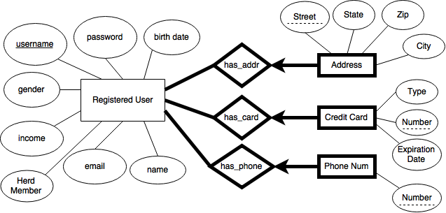

CREATE TABLE Registered_Users (

Name CHAR(30) NOT NULL,

Email CHAR(50) NOT NULL,

Herd_Member BIT,

Income INTEGER,

Gender CHAR(6),

Username CHAR(20) NOT NULL,

Password CHAR (20) NOT NULL,

Date_of_Birth DATE,

UNIQUE (Email, Username),

PRIMARY KEY (Username)

);

CREATE TABLE User_Address

(

Username CHAR(20),

Street TEXT,

Zipcode CHAR(10),

PRIMARY KEY (Username, Street, Zipcode),

FOREIGN KEY (Username) REFERENCES Registered_Users (Username)

ON DELETE CASCADE,

FOREIGN KEY (Zipcode) REFERENCES Zipcodes_Areas (Zipcode)

ON DELETE CASCADE

);

CREATE TABLE Zipcodes_Areas

(

Zipcode CHAR(10),

City CHAR(20) NOT NULL,

State CHAR(20) NOT NULL,

PRIMARY KEY(Zipcode)

);

CREATE TABLE User_Credit_Card

(

Username CHAR(20),

Number CHAR(20),

Type CHAR(20) NOT NULL,

Expiration_Date DATE NOT NULL,

UNIQUE (Number, Type),

PRIMARY KEY (Username, Number),

FOREIGN KEY (Username) REFERENCES Registered_Users (Username)

ON DELETE CASCADE

);

CREATE TABLE Phone_Number

(

Username CHAR(20),

Phone_Number CHAR(20),

PRIMARY KEY (Username, Phone_Number),

FOREIGN KEY (Username) REFERENCES Registered_Users (Username)

ON DELETE CASCADE

);

**4.2 Registered Users (Normalization and Decomposition)**

Registered Users Table

|  |  |  |  |  |  |  |  |
| --- | --- | --- | --- | --- | --- | --- | --- |
| Username | Name | Email | Herd_Member | Income | Gender | Password | Date_of_Birth |

Address Table

|  |  |  |
| --- | --- | --- |
| Username | Street | ZIP_Code |

Zipcode Table

|  |  |  |
| --- | --- | --- |
| Zipcode | City | State |

Credit Card Table

|  |  |  |  |
| --- | --- | --- | --- |
| Username | Type | Number | Expiration_Date |

Phone Number Table

|  |  |
| --- | --- |
| Username | Number |

**9. Bidding**

For the bidding, we have two entities having a relationship. Registered users bid on any of the items that they want. We have our ER Diagram below, but we are going to explain some more of what the SQL statements mean and how they relate to other tables as well. Our bidding table would be created with the following attributes and relationships:

* Username: this is one of the two primary keys and it is also a foreign key that references the registered users table, and it has type CHAR.
* ItemID: this is the second primary key and a foreign key for this table that references Items, and it has type CHAR.
* Amount: this attribute stores that amount of money that the user has bidded. It has type integer.
* Time: this displays the time at which the bid was placed. It has type TIME.
* Whenever a user is deleted, the bids on the items made by the user would be deleted because we have the statement DELETE ON CASCADE.

**9.1 Bidding (ER Diagram 🡪 SQL Statement)**

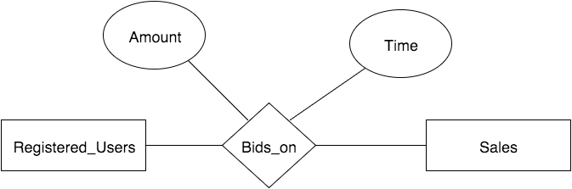

CREATE TABLE Bidding

(

Username CHAR(20),

ItemID CHAR(40),

Amount INTEGER,

Time TIMESTAMP,

PRIMARY KEY (Username, ItemID)

FOREIGN KEY (Username) REFERENCES Registered_Users (Username)

ON DELETE CASCADE,

FOREIGN KEY (ItemID) REFERENCES Items (IID)

ON DELETE CASCADE

);